G&L Motion Control
MMC-SD Application Note

Document Number: AN0051

Topic: Starting Up and Tuning the MMC-SD

Scope
This Application Note applies to the MMC-SD Digital family of products. Much of the information also applies to the MMC-SD Analog. However, there are differences and the drive and PiCPro manuals as well as on line help should be consulted when working with analog drives.

Purpose

This Application Note provides information on starting up and tuning the MMC-SD.

Introduction

The MMC Digital Smart Drives is configured, tuned, monitored and diagnosed through PiCPro for Windows running on a PC. This can be done with all editions of PiCPro (Monitor, Professional or MMC Limited). The Digital Drive requires PiCPro Version 15.1 or later.

Motor Selection is the first step when starting up a drive. If doing the operation while connected to the drive, then the drive model will be automatically detected. If not connected, then the drive model to be used must be selected. The motor model should be selected from the pull down list. If a motor not in the list is to be used, then a Custom Motor File must be created. See the PiCPro manual or on line help for the procedure to do this.

Alignment may be needed for custom motors or for those with resolver feedback. Alignment means to establish an operational relationship between a feedback device and a motor magnetic position. Some types of feedback cannot be aligned using the PiCPro Alignment Mode. After the motor and feedback devices are aligned, the feedback device provides the precise location of the motor magnetic position. Standard motors have the necessary information in the motor database.

For motors with standard quadrature encoders, running an alignment cycle can also serve as a useful check on the correctness of the wiring to the motor encoder connections.

Tuning means to set the gain and other parameters to provide satisfactory performance of the equipment being operated. In order to tune an axis, it must be made to move and the results of the move observed. Adjustments are then made to the loop settings and the move repeated until satisfactory operation is achieved. In most cases equipment does not need to be perfectly tuned to run acceptably and there will be a range of settings where no difference is observed in machine operation.

In a position control system, there are 3 loops involved. These are the current loop, the velocity loop and the position loop.

Settings for the current loop are not adjustable by the user. The current loop is automatically tuned internally to match the selected motor windings. Make sure you select the correct motor from the database or create a custom motor file with accurate data.

Motion initiation and gain settings for the velocity loop are done using the PiCPro Tuning mode and Control Panel. Manual tuning is required and the velocity loop gain settings are adjusted to match the axis load. The load to motor inertia ratio may be determined automatically and can be used to normalize the gain settings.

Gain settings for the position loop are also made using the Tuning mode. Manual tuning is required. Motion of the axis being tuned is done through the MMC_SD Digital Controller ladder diagram.

Factory defaults are set in the drive when the motor type is selected and may be restored from the Factory Defaults tool button if necessary.

Observations of results are done on the oscilloscope as well as by looking at and listening to the machine operation during the process. See the separate application note on Using the Oscilloscope.

WARNING
Using PiCPro to cause motion for alignment or velocity loop tuning requires that the MMC_Dx ladder diagram be stopped. This will defeat any machine safety interlocks that are included in the ladder diagram. Extreme caution must be used in causing motion from PiCPro in order to prevent personnel injury or machine damage.

If a drive input is assigned to Hardware Enable in the drive I/O assignments then it must be turned on or have the assignment unchecked for tuning purposes. If you turn it off, remember to reassign it again when tuning is complete.

Certain tuning selections require that the mechanism be able to reverse to follow the command. If the mechanism cannot reverse or it has more than a minimal amount of backlash, do not use these selections.

Alignment and velocity loop tuning modes are all accessed as follows while on line in PiCPro.

Select Drive Maintenance to get to this screen

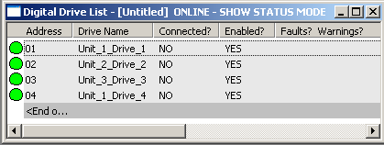

Then double click on the axis to be tuned to get

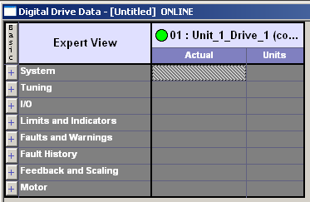

Now select this (green) tool button to get the Control Panel Oscilloscope screen.

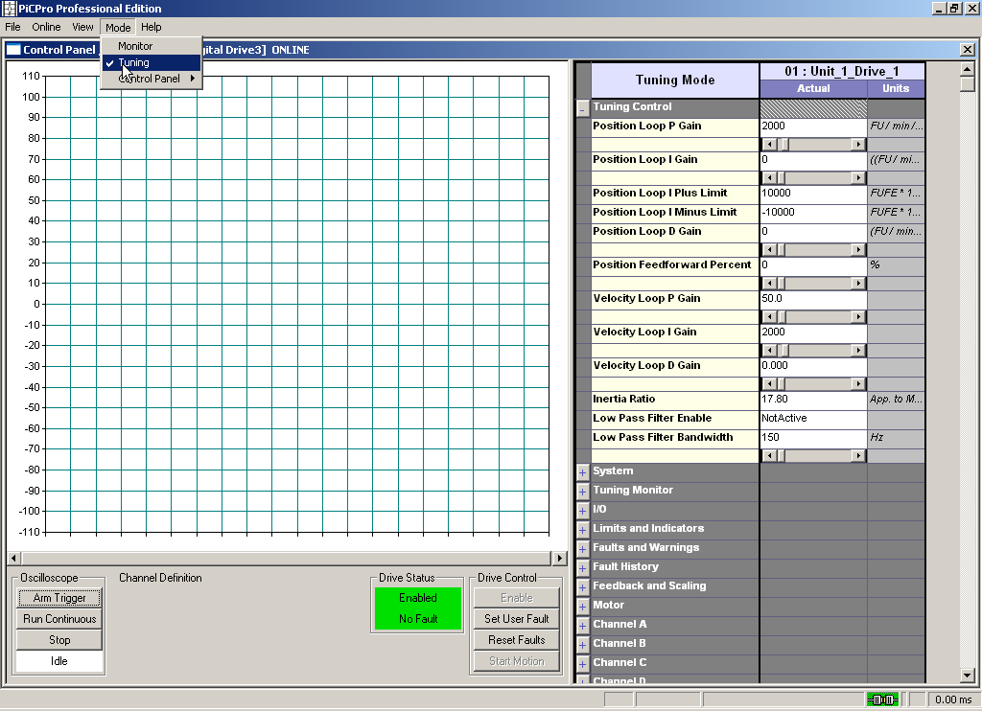

The screen will come up in Monitor Mode. Pull down the Mode menu and check the Tuning entry to get the Tuning Mode pane to the right.

The control panel modes can then be selected from the Mode menu

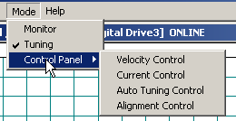

Alignment Control is primarily for use with Custom Motors to establish an operational relationship between a feedback device and a motor magnetic position. After the motor and feedback devices are aligned, the feedback device provides the precise location of the motor magnetic position. Standard motors have the necessary information in the motor database. However, with quadrature encoders, an alignment cycle can also serve as a useful check on the correctness of the wiring to the motor encoder connections.

Alignment Control MUST be run with no load on the motor. It causes the motor to move in small steps by pulsing the individual windings and will not provide the torque needed to move a load.

To run this mode, select it from the menu.

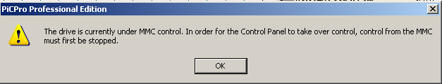

If this message appears, stop the ladder running using the following menu selection

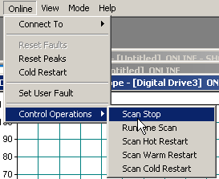

Remember this will defeat any ladder safety interlocks that are running and if you are using a drive input as hardware enable, you must either supply that signal or uncheck the appropriate input in the drive I/O assignments as shown. If you do the latter, remember to check it again when tuning is complete.

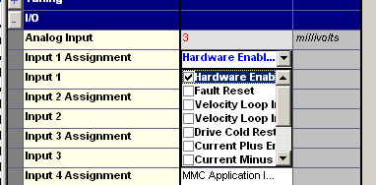

Set the current you want to use here.

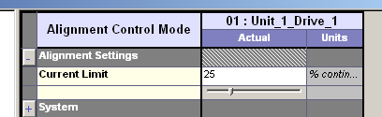

Enable the drive and start the motion from these buttons

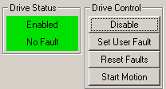

A successful alignment mode for a standard motor with quadrature encoder will appear as something like this

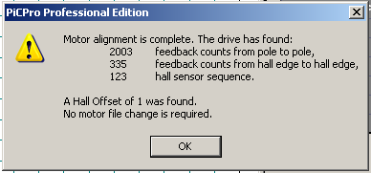

The Hall sensor sequence must be 123. Check sensor wiring if this is not the case.

The expected feedback counts from pole to pole = encoder counts per rev / number of pole pairs in the motor. In this case, we have a 2000 line per rev, 8000 count per rev encoder and an 8 pole (4 pole pairs) motor. So the expected number is 8000/4 = 2000. If this number is not within a small tolerance of this value, the following will appear

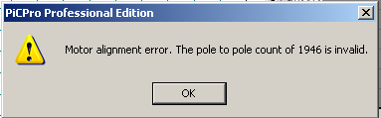

If this occurs, try raising the motor current being used and repeating the alignment motion. There may not have been enough current being used to drive the motor correctly.

If the problem continues and you are sure all the other wiring is correct, make sure that the common of the 24 volt supply to the drive is connected to single point ground as described in the hardware manual.

The feedback counts from Hall edge to Hall edge = 1/6 x (encoder counts per rev / number of pole pairs in motor) = 1/6 x 8000 / 4 = 8000/24 = 333 in this case.
For more information on Alignment Mode and Custom Motors, see PiCPro 15.1 Help Chapter 4 Alignment Mode.

Encoder and Hall Effect signals can be checked from the following window and its fields.

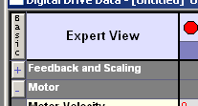
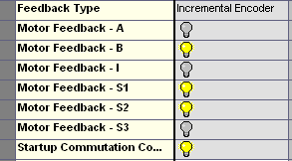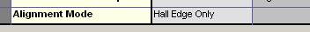

The S1, S2, S3, A and B signals will be seen to change as the motor rotates. The I signal is only 1 pulse per rev and will probably not be seen. If the I signal is on all the time, it likely means that the I and I- wiring is crossed. If so, it should be corrected. The I channel must be connected or a loss of feedback will occur. Note that the Alignment Mode uses the Hall Effect sensor edge only and not the encoder markup pulse for start up commutation. Earlier generation drives used the Hall Effects followed by the I channel marker pulse for start up commutation. Startup Commutation Complete shows whether this condition has been met. Drive fault 22 may also indicate a Hall problem.

If an Alignment Mode cycle cannot be completed, there is a problem and it must be fixed before proceeding. The problem may be the drive or the motor or the wiring between them. It may also be caused by incorrect drive selections such as the type of motor or feedback device.

If the second feedback connector is being used for a separate encoder and it does not have an I signal, wire the I connection to 0 volts and the I- to + 5 volts. This will defeat the loss of feedback detection. There are no state indicator lights for the F8 connector. If F7 is set up for a motor with quadrature encoder feedback, then plug the encoder into that connector and use its lights for troubleshooting.

Introduction to Tuning

The amount of tuning needed will depend on the performance required of the equipment. Having loops tuned to produce softer performance will reduce shock on the machine and help to prolong equipment life. Improper mechanical design and choice of components may limit tuning settings and performance.

This is a simplified diagram of the velocity loop. The user adjustments are shown with a gray background.

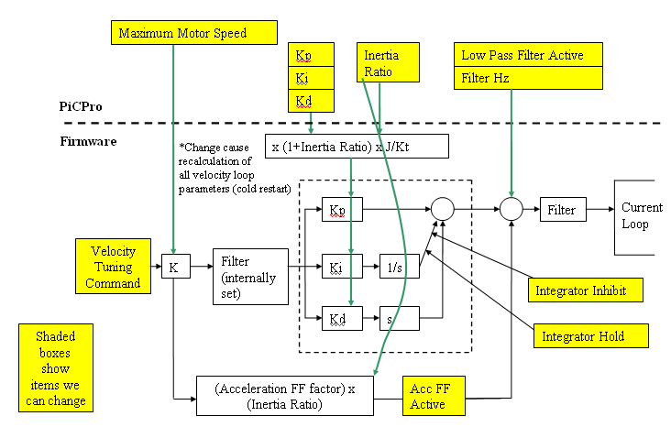

Maximum power will be delivered to a load when there is an inertia ratio of 1:1, but in practice this number can get much higher. The higher it is, the less responsive the system will be. Inertia ratio plays a major role in good velocity loop gain setting values. In essence, the higher the total inertia, the higher the internal gain values required for the loop to work well.

The relationships and equations that determine the output of the velocity loop are such that load inertia acts as a divisor on loop output. The higher the inertia and therefore Inertia Ratio, the higher the gains need to be set to produce the same results at the output for a given error at the input.

There is an Inertia Ratio field in the drive parameters that can be used to automatically compensate the loop gains, allowing similar entered values to be used for axes with different inertias.

The proportional, integral and derivative gain values used in the velocity loop are calculated by the following equation from the values entered in PiCPro.

K(loop) = K(entry) x (1 + Inertia Ratio) x J/Kt

where J is the motor inertia and Kt is the motor torque constant.

J/Kt gives an automatic loop gain adjustment based on the inertia and torque constant of the motor being used. These come automatically from the motor database when the motor being used is selected during drive configuration.

It can be seen by inspection of the equation that the higher the inertia ratio, the higher will be the K value used in the loop for the same K value entered by the user. This allows the use of known good starting values for the entries provided the inertia ratio is known.

If the Inertia Ratio is set to zero, then the loop values are essentially the entry values. Having a 0 value for Inertia Ratio also has the additional effect of turning off Acceleration Feedforward, as can be seen by looking at the Acceleration Feedforward equation in the diagram. Acceleration Feedforward may also be turned off by a separate setting available for that purpose.

Inertia ratio can be entered manually from the machine design and servo sizing calculations, or it can be measured automatically using the auto tune feature.

The default value for Inertia Ratio is 0. As explained, if this field is left at zero, then the gain values entered will be the ones used in the loop itself. The choice is up to the user.

Velocity Loop Tuning Options

Auto Tuning

Auto Tuning will not automatically determine the best tuning parameters for an application. Its purpose is to determine the load to motor Inertia Ratio and suggest typical Kp, Ki and Kd values for the velocity loop as a good starting point for final manual adjustment. In many applications, these settings may perform perfectly well. However, it is up to the user to determine if this is the case or if further adjustment of these and other parameters is needed. In cases where the inertia can change significantly during a machine cycle, the value should be measured under each different condition.

Auto tuning operates by using the current and distance settings to move the motor through several cycles. The position and speed responses of the motor are captured and calculations done to determine the load inertia. This is then divided by the known motor inertia and displayed as the application Inertia Ratio.

Auto Tuning Control Panel Mode allows the user to setup and execute an auto tune cycle. While executing the auto tune cycle, the drive is under software control and being operated in current mode. The Current Limit parameter is a percentage of the motor continuous current and the Distance Limit parameter sets the number of revolutions of the motor for the forward and reverse stroke of the auto tune cycle.

Select Auto Tuning from the Mode Control Panel menu

These are the settings we will be working on in the Tuning Control Panel. The values shown here are the defaults that are put in when a drive is initialized. Note the default Inertia Ratio is 0, so the gain entries are essentially the loop values.

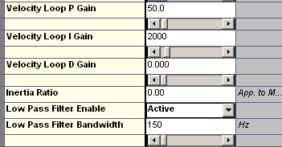

In tuning, the Low Pass Filter should be turned off. Click in the field and select Not Active.

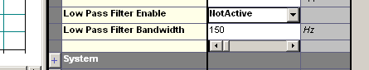

These are the selections you need to make. Adjust the current and distance limits to suit the equipment you are working on. Start low and work up to values appropriate to your machine. Current limit range is 2% to 50% continuous motor current. Distance range is 0.1 to 10.0 motor revs

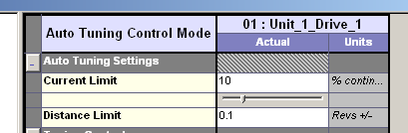

Motion is initiated by the Start/Stop Motion button in the Drive Control group of the Control Panel.

The drive will oscillate for a few seconds and then stop. The auto tune cycle can be stopped at any time by clicking the Stop Motion button.

Select Yes if you want to accept the numbers shown. Note the inertia ratio and click No or Cancel to close the dialog without updating the parameters in the drive.

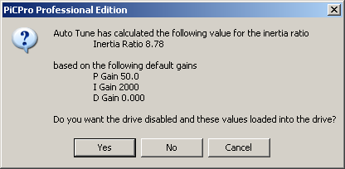

No matter what the Inertia Ratio is calculated to be, the same entry values for P, I and D gains are recommended here. Remember from the earlier introductory discussion that the values used in the loop are the entry values multiplied by (1 + Inertia Ratio). In our case here, the Inertia Ratio is 8.78:1. If the cycle is run again, the result may differ slightly but should be within 10%. Choose Yes to enter the values if you wish to use the Inertia Ratio feature. If not, choose No

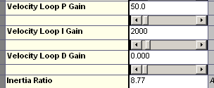

The benefit of having the Inertia Ratio value entered is that it will normalize the P, I and D gain values between applications. That is, the values entered will be in a similar range no matter what the application inertia is. As a result, it will be possible to determine if the velocity loop gain settings are close to the typical range. The normalized P gain will typically fall between 30 and 80 and the I gain between 100 and 3000. The D gain should be left at zero under normal circumstances. Consult Technical Support for further information.
Manual Tuning

This is the recommended method even if Auto Tuning has been run.

Select Velocity Control in order to proceed with manual tuning.

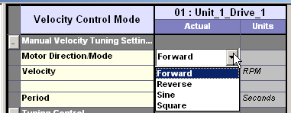

There are 4 options for manual tuning.

- Forward
- Reverse
- Sine
- Square

All 4 offer velocity control from 0 to full speed motor rpm. The sine and square wave options also offer period control selectable at .25, .5, 1.0, 2.0, 5.0 or 10.0 seconds. This equates to 240 Hz down to 6 Hz.

The sine and square wave selections require that the mechanism be able to reverse to follow the command. If the mechanism cannot reverse or it has more than a minimal amount of backlash, do not use these selections.
The drive is using Velocity Control for these modes and this will result in the motor drifting in position. Do not leave either of these modes running for periods of time if it is possible for the machine to be damaged if its position drifts too far.

The sine function is typically for use in determining the frequency response of the loop and should not be used for gain tuning. The forward and reverse modes can be used by starting and stopping the drive manually or the square wave selection will produce the change in motion needed automatically.

To use Forward or Reverse Tuning, select the speed and the direction required. The period entry has no function with these moves.

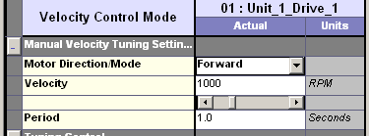

To use square wave, select velocity and period.

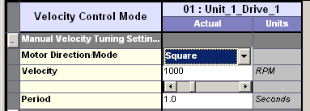

Oscilloscope Settings

See also the application note on using the oscilloscope for more information.

Set up the oscilloscope traces to show motor commanded and actual velocities as well as the drive current. The signals used here will be found in the Tuning Control branch in the tree that appears when the Signal field is opened.

Tuning will consist of making adjustments to get the motor velocity waveform to match the Velocity Command. The tuning must be done without reaching the maximum motor current. This is the reason for it being displayed. Deleting it from the selections will allow more data on the other 2 channels to be trapped, but this should only be done once it is known that it is not reaching a maximum value at any point.

The Scale settings should be set as near as possible to the values being used, but they can be adjusted at any time for better viewing. Velocities are in motor RPM.

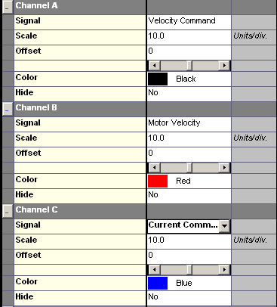

For forward or reverse moves, enable the drive and start and stop it from the drive control buttons so you can observe the changing scope traces. For the square selection, the motor will reverse automatically, making it easier to see the results of changing the gains. Selecting Continuous in the Trigger Mode will make observing the effects of changes easier as the oscilloscope will retrigger automatically each time a move is initiated.

In the example that follows, we will be using a square wave with a period of 1 second and 120 rpm amplitude. Initially at least, we want to make sure that the current required does not exceed the drive capability. So we need to have 3 traces showing command velocity, motor velocity and current feedback. This means we can have 300/3 = 100 samples in the 1 second period, so we need a sample time of 10 ms. If necessary, once the current is seen to be at a safe level, the channel can be undefined and the samples available rise to 150. This means the sample time can be changed to 6 ms and we can still see the full wave but with better resolution.

To manually tune from scratch, start by zeroing the I entry and setting the P gain at a low level. This level should be enough to just make the axis respond. We will start with a value of 1.

Starting the square wave motion showed the following scope trace.

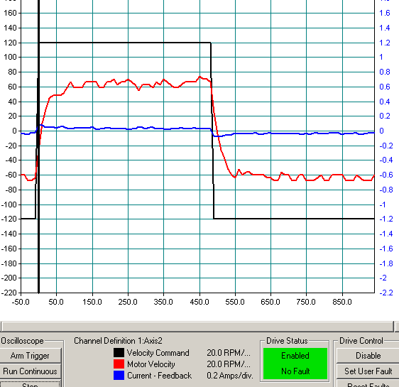

The square trace is command velocity reaching 120 rpm and the motor velocity is the one that gets up to about 70 rpm only. The other waveform is current and is well below drive rating, so it will be eliminated from the screen for clarity from now on.

It also has the benefit of increasing the time period captured as can be seen from the trace X axis. The capture time can now be changed to 7 ms for better resolution.

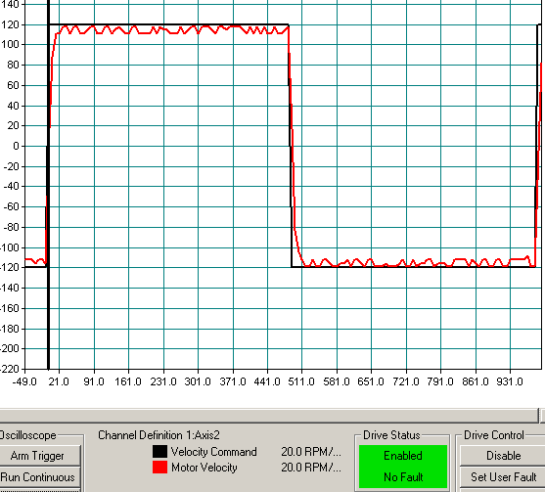

The P gain has been raised to 10 and the sample time changed to 7 ms to allow more data to be captured. This gain setting may be perfectly acceptable for a given application. It has no overshoot in the response. The lower the P gain setting, the more stable the system will be at the expense of response. For better machine performance, the P gain should be raised until there is overshoot. Overshoot will last for only a short time and it is better to speed up the sampling to be sure of capturing it. This will result in not seeing all of the waveform, but we are interested in the velocity change area. So changing the sample time to 1 ms is now required to better capture the information.

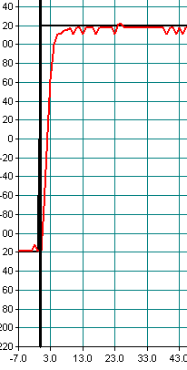
Figure 1 Kp 20 No Overshoot

The sample time is now 1 ms so the leading edge overshoot can be seen in more detail.

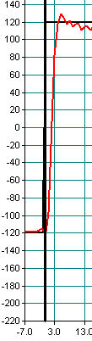
Figure 2 Kp25 8 RPM Overshoot

Note that the actual now overshoots the command by about 8 rpm before returning to the same as the commanded velocity.
This is about 6% and may be too high for some applications.

In demanding applications, it is important to raise Kp as high as possible.

Remember that too high a Kp may cause instability.

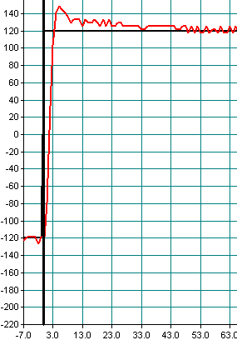

Figure 3 Kp 25 Ki 1000 25 RPM Overshoot

Ki can now be raised also. It will cause further overshoot, in this case 25 rpm, which is 20% and is likely too high for any real world application.

10% is a more typical maximum value.

The procedure is called Tuning for a reason. It is as much an art as it is a science. So you need to use your knowledge of the machine and its performance capabilities and requirements to determine what an acceptable results level is.

Turn the Low Pass Filter setting back to Active.

The velocity loop is now tuned. Save the settings to a drive DDV file so that there is a record of them and they may be restored at any time if the drive should need replaced or a repeat machine built.

Revision History

Date: July 29, 2026
Author: John Boyle
Changes: Original

Date: [For each revision, enter the date revised,]
Author: [the name of the person revising the document,]
Changes: [and indicate what changes were made.]

